Feature list front-end

**Front-Page**

1. **Search bar**

*What is it?*

A Search bar

*What is its purpose?*

Looking for engineers and / or products

*How does it work?*

o Seeks the name of the engineer and the machine simultaneously

o Results will all appear as you type.

o Can filter the results by country and more.



1. **Product list**

*What is it?*

A list of names

*What is its purpose?*

The display of products that is sought out for.

*How does it work?*

o List of products that are sought after, which depends on what you type in the search bar.

o On a mouse-over of a name, change the colour of the selection to make it clear that you have selected this name to blue.

o There will be a picture of the product to the right of the product list if the product has been clicked on. In the engineer list you will also be able to see what skills the engineers have.

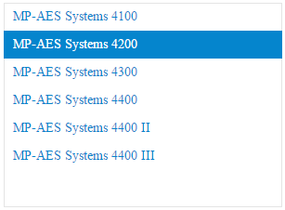

1. **Product information**

*What is it?*

A field of information

*What is its purpose?*

Displaying information about the product you just selected

*How does it work?*

* + The information of the selected product will be shown. This includes: the name and the image of that product.

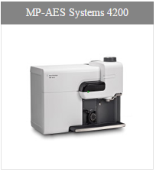

1. **Engineer list**

*What is it?*

A list of names

*What is its purpose?*

The display of engineers that is sought out for.

*How does it work?*

* + A list of engineers which will reduce the more you type in the search bar.
  + The colour of the space in which you clicked will change to blue to show that you clicked on that name.
  + There is also a pop-up notification on mouse over of a name. This shows the status of this engineer (Sick, Vacation, etc)
  + Next to the engineers name is also a title which include ASP and FFS. In addition, the flag of their country of origin is also shown.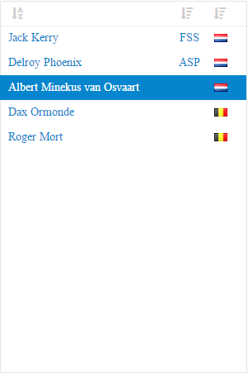

1. **Engineer Information**

*What is it?*

A list of names

*What is its purpose??*

Displaying information about the engineer you just selected

*How does it work?*

* + If an engineer is selected there will be an info block with the following information: The name, the level, a picture, a drop point, a telephone number, an e-mail, the number of this employee, the SCC, the date when the VCA was achieved, the license plate number of the used car, the car brand, his/her street , his/her zip code, his/her street number, the city, the country, the spoken languages.

Also, if an engineer is selected, the devices he/she is trained for will show up in the “Products Field”.

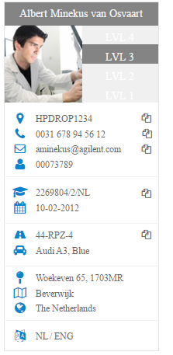

*Front end 1 is if you didn’t select anything

*Front end 2 is if you selected everything.

Front end 1

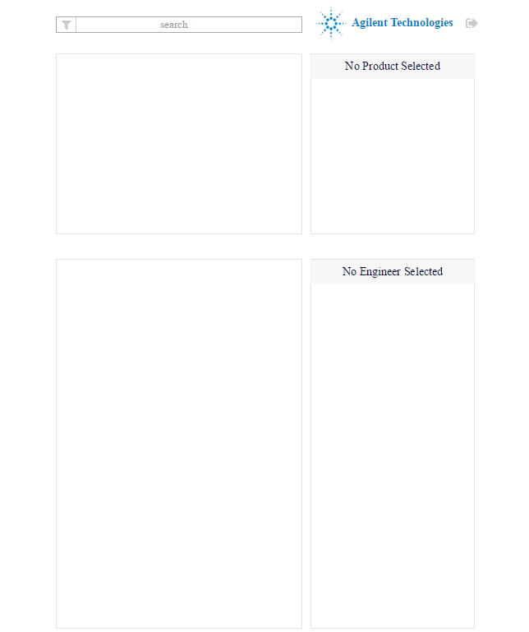

Front end 2

